SOFTWARE DEVELOPMENT PROPOSAL

### PREPARED FOR

Client’s name

Client’s company name

### PREPARED BY

Your name

Your company name

[YOUR COMPANY’S LETTERHEAD]

JUN 07, 20XX

### CLIENT’S NAME

### CLIENT’S COMPANY NAME

123 CLIENT STREET

CLIENT CITY, ST 12345

Dear [CLIENT’S NAME],

Re: Enclosed Software Development Proposal

Please find enclosed our detailed software proposal for your kind consideration.

At [YOUR COMPANY’S NAME] we are aware that creating client-oriented software takes a mixture of technical excellence and clear communication and our firm hires only the very best to ensure you receive both. We know that every client is unique and we strive to deliver an individual, innovative and affordable proposal every time and to follow it through with an outstanding delivery which is both on time and within budget.

We have over [YEARS] of development in this area and our previous clients include [PREVIOUS CLIENTS]. Please let us know if you would like to get in touch with our existing clients from whom you will receive nothing but positive endorsements. You may also wish to review our website at [WEBSITE] to see our portfolio of previous work and learn more about our organization.

We also pride ourselves on our after-sales client-care including our guarantees, staff-training and onsite and offsite support.

Finally, we realize that you are very busy and wanted to thank you in advance for your time spent reviewing our proposal.

Yours Truly,

[YOUR NAME]

EXECUTIVE SUMMARY

[150-600 word summary of the report that provides a high-level overview of the project]

| Signed as accepted by client: |  |
| --- | --- |
| [NAME], [TITLE] | [DATE] |

# 1. Project Overview

[A detailed description of the project stating the aims, scope and intended operation]

# 2. Obstacles

[A description of the possible risks involved with the project and how you will manage them]

# 3. Technical Obstacles

[Any technical obstacles like integration between different systems, as well as mitigation strategies]

# 4. Industry and Market Risks

[Any industry or market-related risks]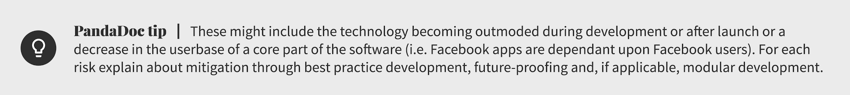

# 5. Budgetary Risks

[Budgetary risks]

# 6. Hardware

[The hardware that the proposed software will be compatible with]

# 7. Software

[A list of software technologies that will be used in the development of the proposed software]

# 8. Milestones and Reporting

### Total estimation of man hours: 226

| **Milestone** | **Tasks** | **Reporting** | **Hrs** | **Date** |
| --- | --- | --- | --- | --- |
| **1 - Analysis** | | | | |
| 1.1 | Analysis and design stage, gather data and create system mockup | None | 20 | 20/01/15 |
| 1.2 | Architecture design | None | 4 | 01/02/15 |
| 1.3 | Design work plan (distribution of tasks to development teams) | Client meeting to review work plan | 10 | 07/02/15 |
| **2 - Development** | | | | |
| 2.1 | Create database | None | 5 | 14/02/15 |
| 2.2 | Import existing client data | None | 5 | 21/02/15 |
| 2.3 | Clean data | None | 5 | 28/02/15 |
| 2.4 | Create GUI | Client meeting to review GUI | 30 | 01/04/15 |
| 2.5 | Integration with PaperlessOffice.net | None | 10 | 14/04/15 |
| 2.6 | Integration with smartphone network | Email report | 10 | 21/04/15 |
| **3 - Testing** | | | | |
| 3.1 | Alpha testing desktop application (Closed) | Email report | 25 | 07/05/15 |
| 3.2 | Alpha testing smartphone application (Closed) | None | 25 | 14/05/15 |
| 3.3 | Open Beta (volunteer employees) | Client meeting | 22 | 21/05/15 |
| 3.4 | Finalise documentation | None | 20 | 28/05/15 |
| **4 - Deployment** | | | | |
| 4.1 | Deployment to desktops | None | 5 | 01/06/15 |
| 4.2 | Deployment to smartphones | None | 10 | 07/06/15 |
| **5 - Training** | | | | |
| 5.1 | Inhouse training | Client meeting | 16 | 14/06/15 |
| 5.2 | AdHoc training | None | 4 | 30/06/15 |